**Assignment No. 4**

* ***Aim:***

Measurement of Power - Single phase, multi-phase, balanced and unbalanced, active, reactive, and apparent power.

* ***Apparatus:***

Single / 3 – Phase Connection, smart meters, connecting wires, lugs, advance stripper, Current Transformer (CT) and Voltage Transformer (VT), Load Bank.

* ***Objective:***

To demonstrate the configuration and setup of digital meters to measure the electrical parameters.

* ***Outcome:***

Students will be able to:

1. Configure/Setup and use instruments/digital meters to measure

electrical parameters.

2. Measure active, reactive and apparent power.

* ***Theory:***

Active Power (P): Represents the actual power consumed by the resistive part of the load, measured in watts (W).

Reactive Power (Q): Represents the power associated with the inductive or capacitive components of the load, measured in volt-amperes reactive (VAR).

Apparent Power (S): The vector sum of active and reactive power, measured in volt-amperes (VA).

Power Factor (PF): The ratio of active power to apparent power. It is a measure of the efficiency of power usage.

* Connections :

-Connecting wires were fixed with lugs to obtain better connectivity

-Connections in the order Source-Smart meter-Load Bank

-Three types of load banks : Capacitive, Resistive and Inductive but only inductive and resisitive loads were used.

* ***Images:***

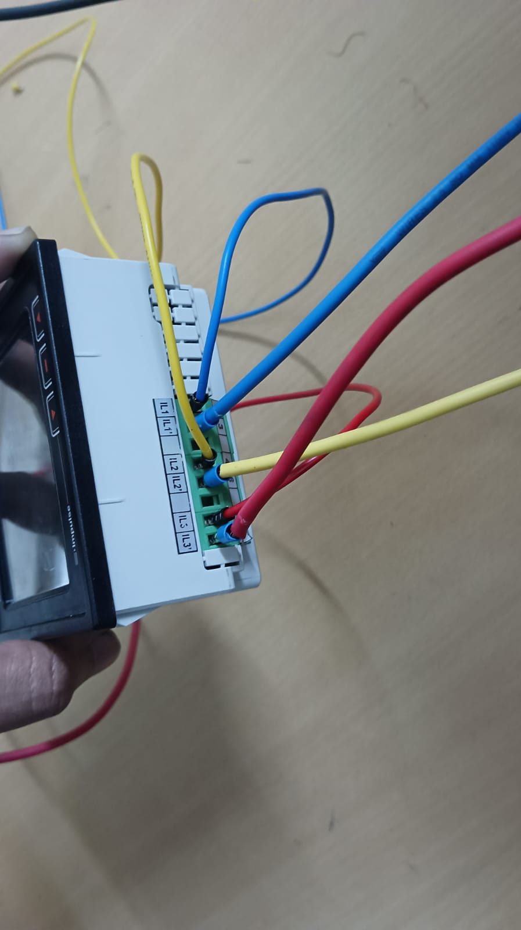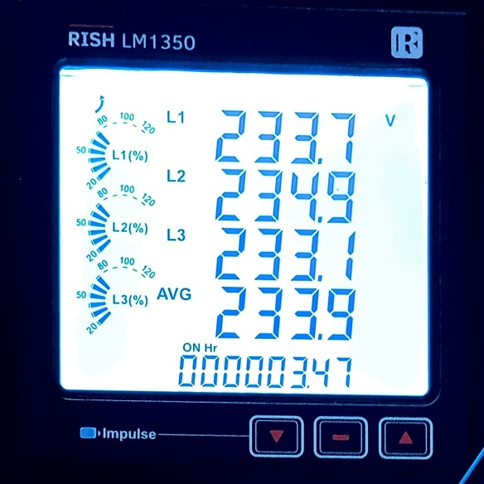

**Figure 1: Smart Meter Connections** **Figure 2: Phase Voltages**

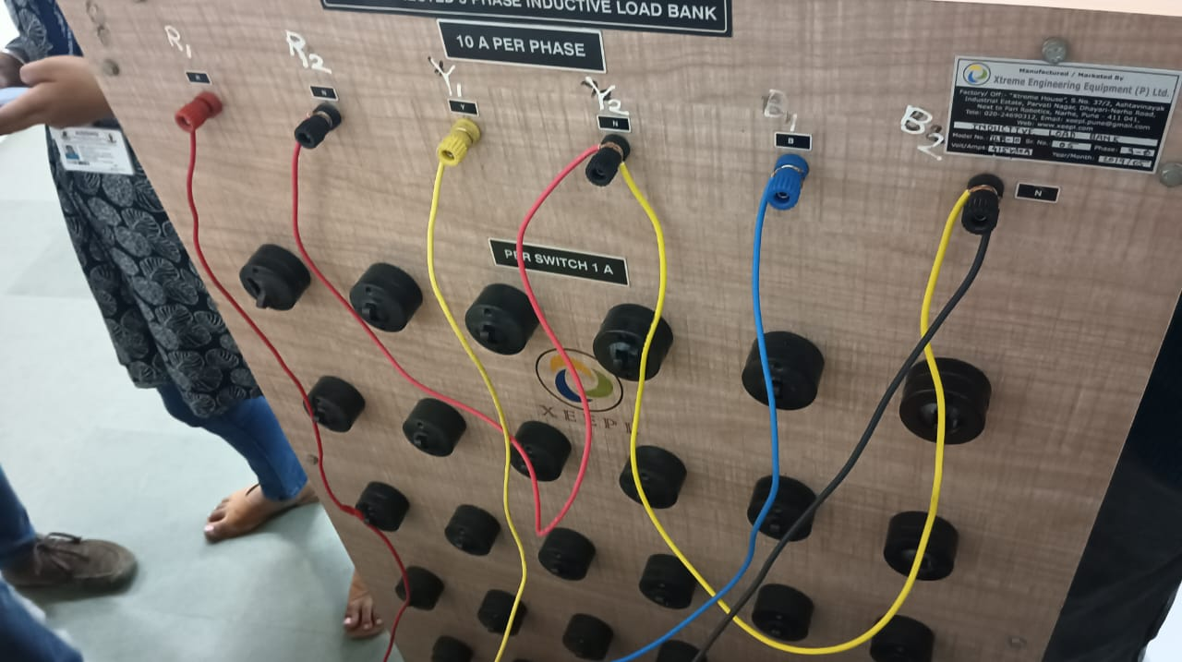 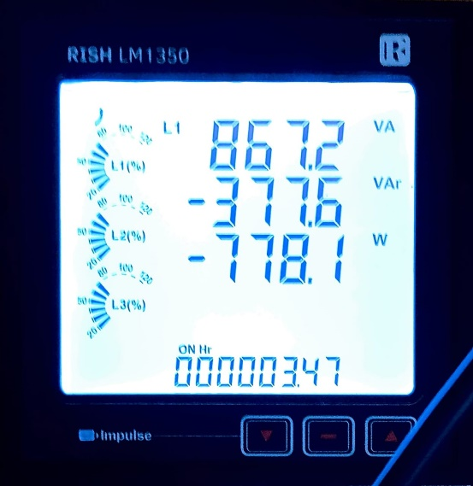

**Figure 3: Load Bank Figure 4: Power**

* ***Result:***
  + - **3 - Phase Voltage (in volts) :** VR=233.7 V, VY **=**234.9 V, VB **=233.**1 V
    - **Power :** Active PTotal = 778.1 W

Reactive PTotal = 377.6 VAr

Apparent PTotal = 867.2 VA

* ***Conclusion:***

Apparent, Active, Reactive Power was obtained using smartmeter.